PLAIN PACKAGING

What is it, and why is it needed?

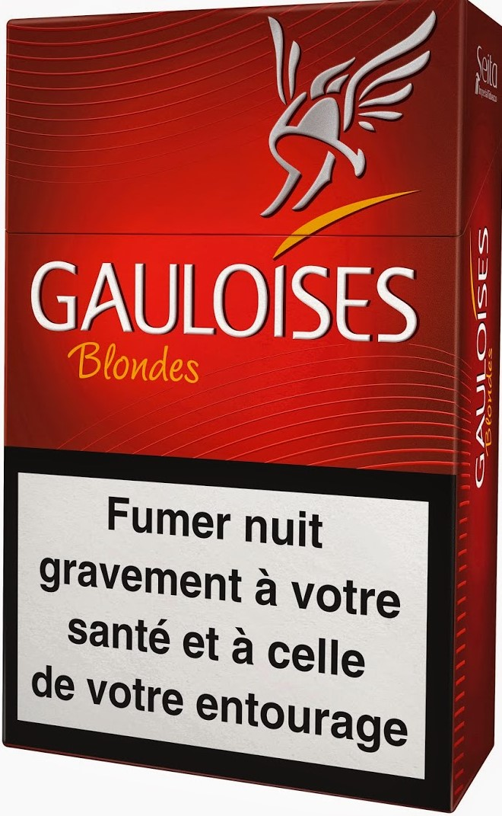

What is plain packaging of tobacco?

Plain packaging of tobacco is a common-sense policy that removes the promotional, marketing, and advertising features on packs of tobacco, but leaves the health warnings, tax stamps, and other features required by government. Most governments have increased the size of the health warnings at the same time as introducing plain packaging. The main elements of a plain packaging of tobacco policy are:

* packaging must be a **uniform plain unattractive color** usually a dull brown/green;
* 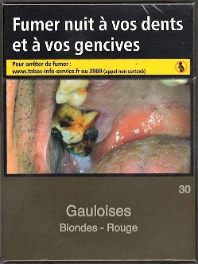all packs must be a **standard shape, size** **and texture**, and be made from cardboard;
* **no branding, logos, or other promotional elements** can appear on the packaging or on individual sticks; and
* the brand and product name can appear on each pack, as well as the quantity of product in the pack and manufacturer’s contact details, but in a standard size, color and typeface.
* Health warnings, tax stamps and other government requirements remain.

Plain or standardized?

The most commonly used term for the policy is “plain packaging” — this is the term used by Australia and the WHO. But because packs retain the health warnings, they are not literally “plain,” and the industry has tried to spread confusion about this. In the UK and Ireland, the term used is “**standardized packaging**.’” In France, the term used is “**neutral packaging**” and elsewhere governments have called it “**generic packaging**.” These are all different terms for the same policy.

Examples of Gauloises cigarette packets in France before and after plain packaging.

Why is it needed?

AUSTRALIA “IS ACQUIRING OUR BILLBOARD”

In the legal claim in the Australian High Court, counsel for Japan Tobacco International argued that tobacco packaging acted like an advertising billboard.

**Packaging for all products can act as a form of promotion, marketing, and advertising**. This is even truer for tobacco because in countries where other advertising is restricted, the pack becomes the main means of promoting tobacco. Moreover, tobacco is a “badge product” that people carry around with them and display every time they take the pack out.[1] Brightly colored and attractive branding distracts attention from the health warnings and works to create misperceptions about the how dangerous and addictive tobacco is.

How will plain packaging work?

Plain packaging helps to change smoking attitudes and behaviors and reduce the overall demand for tobacco. It is likely to have a greater impact on younger people. Plain packaging will:

* **reduce the appeal and attractiveness** of tobacco products to consumers;
* **increase the noticeability and effectiveness of health warnings** on the packaging of tobacco products; and
* **reduce the ability of the packaging of tobacco products to mislead consumers** about the harmful effects of smoking or using tobacco products

“Our final communication vehicle with our smoker is the pack itself. In the absence of any other marketing messages, our packaging...is the sole communicator of our brand essence. Put another way—when you don’t have anything else—our packaging is our marketing.” BAT executive.

Which countries already have plain packaging?[2]

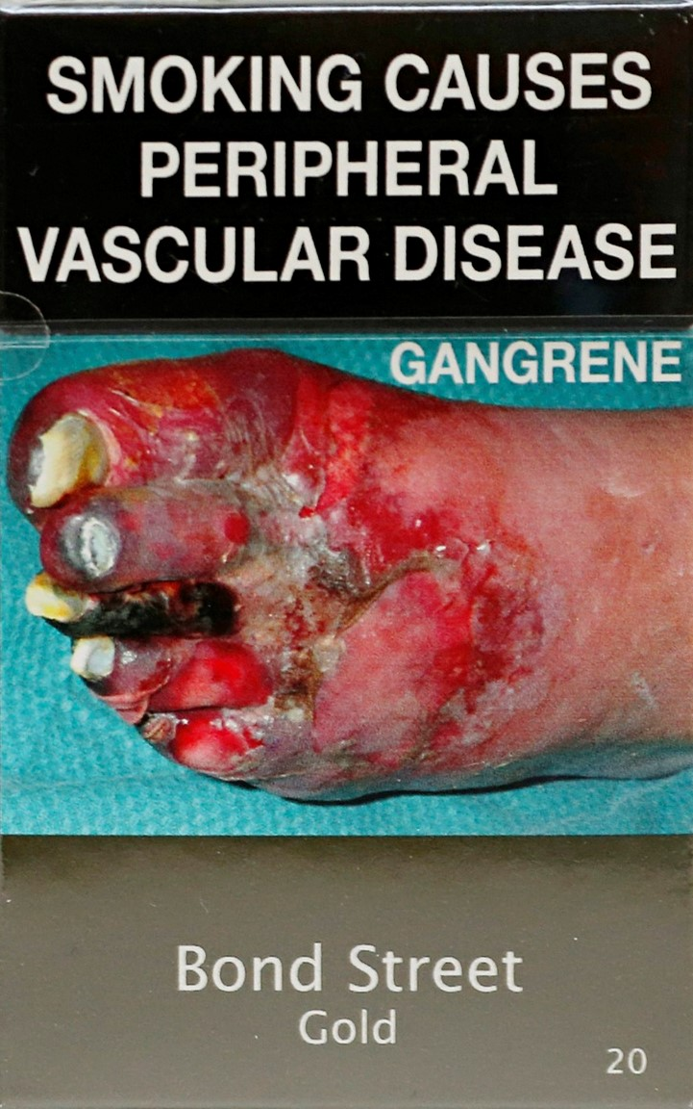

**Australia** was the first to introduce the policy in 2012. Since then, **France** and **the UK** have brought it into force. **Ireland, Hungary, Norway, and New Zealand** have all adopted plain packaging laws that should be implemented during 2017 and 2018. As of January 2017, many other countries governments have legislation before parliament or are seriously considering the policy, including **Canada, Belgium, Slovenia, Uruguay, Thailand, South Africa, Chile, Singapore, and Sri Lanka**.

Does it work — what does the evidence say?

Yes. There have been **five international systematic evidence reviews** that considered all the peer-reviewed research studies from around the globe on the impact of plain packaging on smoking behaviors and attitudes.[3] All concluded that the policy would be effective at contributing to its objectives.

In Australia, over four years of post-implementation data shows continued significant declines in smoking rates.[4] The government’s post-implementation review concluded that a 0.55 percentage point drop could be attributed to plain packaging (**equivalent to 118,000 fewer people smoking**[5] **over three years**).

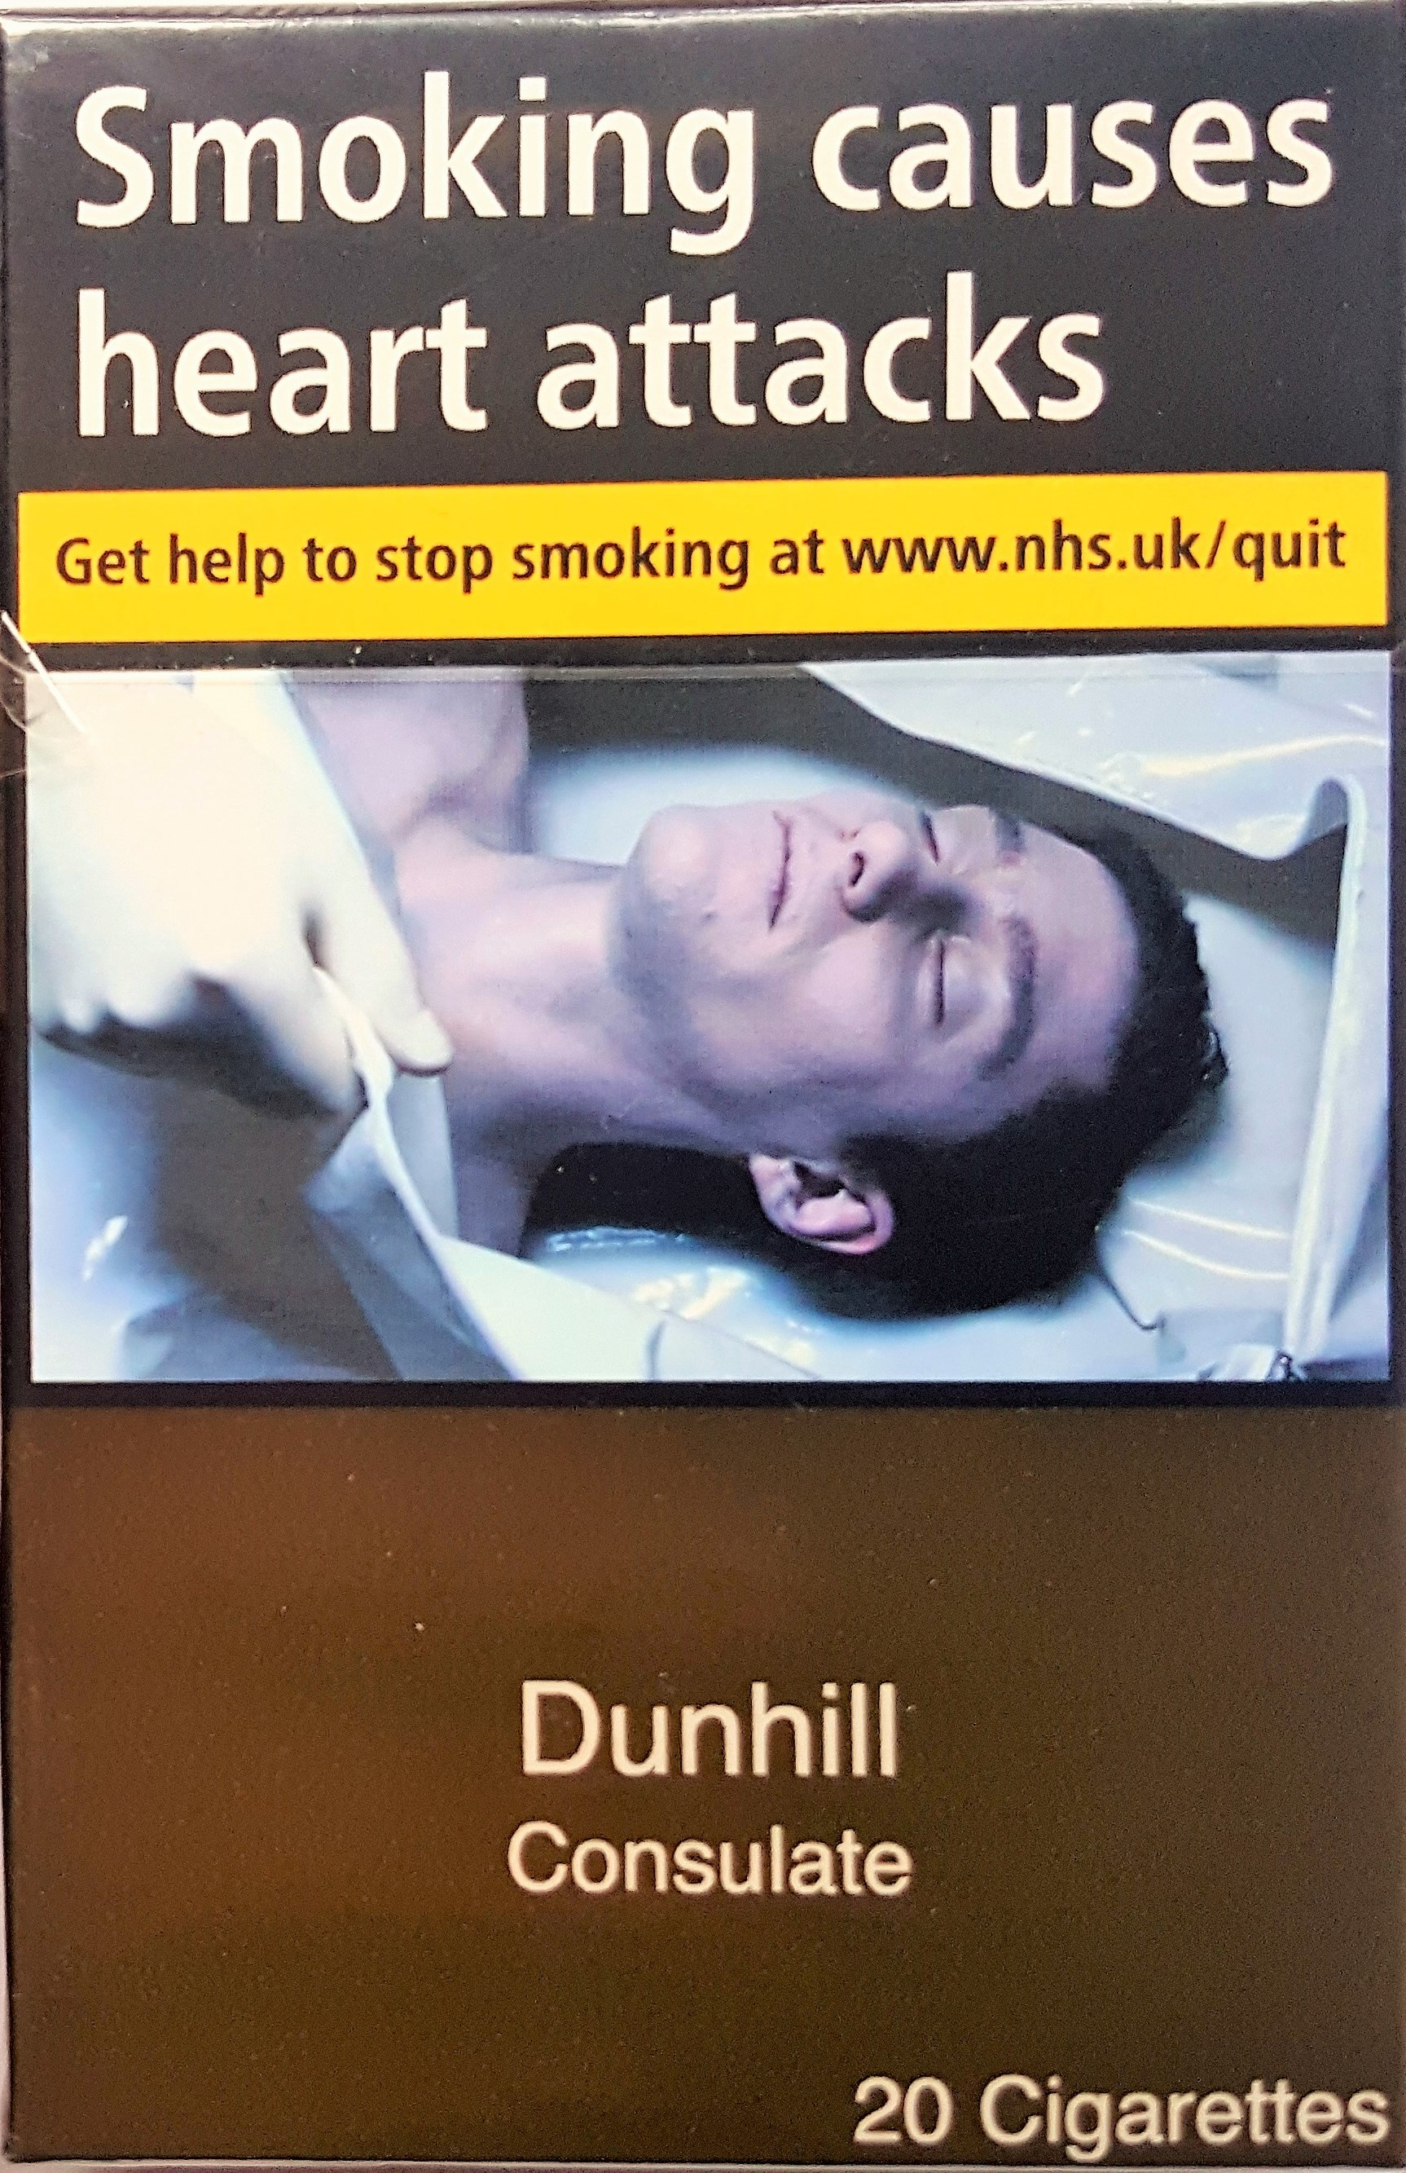

The tobacco industry has refused to release any of its own internal research into the impacts of plain packaging. The studies the tobacco companies rely on to oppose plain packaging are almost universally not peer reviewed, are unverifiable, and either ignore or airily dismiss the global evidence that supports the policy being effective.[6]

Is it lawful?

Yes. Plain packaging is recommended by the implementation guidelines to articles 11 and 13 of the Framework Convention on Tobacco Control[7] — one of the most widely ratified international treaties in the world.

The tobacco industry tries to argue that plain packaging breaches the World Trade Organization agreements, intellectual property laws, and national constitutions. These arguments have been consistently rejected by national and international courts and tribunals.

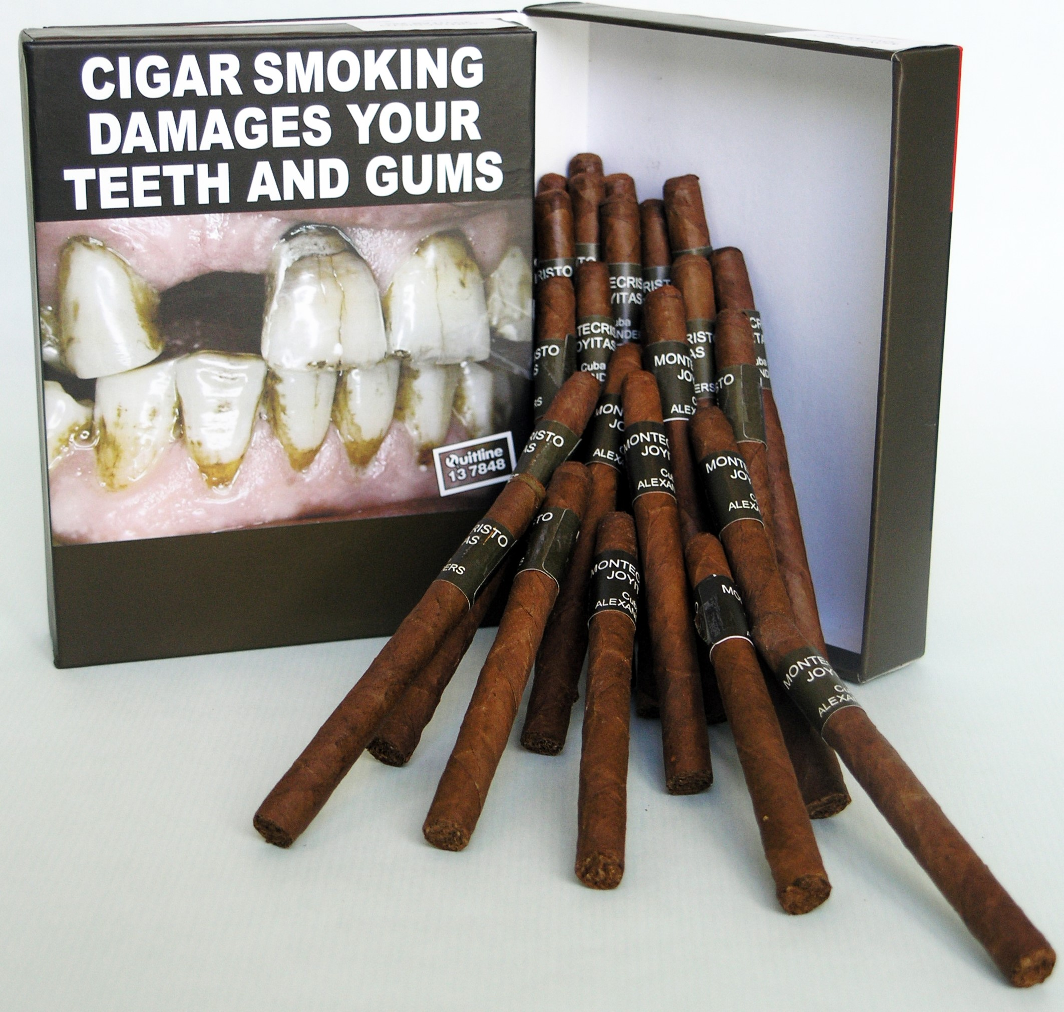

The tobacco industry has brought legal challenges to plain packaging legislation in Australia, the UK, France, and Ireland.[8] **All these legal claims have been dismissed or struck out**. Philip Morris also tried to bring an international investment arbitration claim against Australia, which the tribunal dismissed as being an “abuse of rights.”[9]

1. M. Wakefield et al. The cigarette pack as image: new evidence from tobacco industry documents. *Tobacco Control*. 11(suppl.1):i73−i80, 2002. Available from: <http://tobaccocontrol.bmj.com/content/11/suppl_1/i73.full>.
2. An up-to-date list of countries adopting legislation or considering the policy is available from: <http://global.tobaccofreekids.org/files/pdfs/en/standardized_packaging_developments_en.pdf>.
3. The Cancer Council Victoria (Australia 2011) is available from: <http://www.cancervic.org.au/plainfacts/plainfacts-evidence>; the Stirling Review (United Kingdom 2012 and updated 2013) is available from: <http://phrc.lshtm.ac.uk/project_2011-2016_006.html>; the Chantler Review (United Kingdom 2014) is available from: <http://www.kcl.ac.uk/health/10035-TSO-2901853-Chantler-Review-ACCESSIBLE.PDF>; and the Hammond Review (Ireland 2014) is available from: <http://health.gov.ie/blog/publications/standardised-packaging-d-hammond/>; The Cochrane Review (2017) is available from <http://onlinelibrary.wiley.com/doi/10.1002/14651858.CD011244.pub2/abstract>.
4. The Australian government’s Post-Implementation Review was published in February 2016 and concluded that plain packaging has had a positive impact. Available from: <https://ris.govspace.gov.au/2016/02/26/tobacco-plain-packaging/>.
5. See <http://www.ft.com/cms/s/0/6248cfee-11e3-11e6-91da-096d89bd2173.html#axzz48RqRYYOE>.
6. The judge in the UK High Court case highlighted that the tobacco industry had not disclosed any of its own research and data and heavily criticized the experts the tobacco companies relied on. See note 8 for case reference.
7. See <http://www.who.int/fctc/guidelines/adopted/guidel_2011/en/>.
8. i) R (British American Tobacco & Ors) *v.* Secretary of State for Health [2016] EWHC 1169 (Admin) ii) JT International SA *v.* TheCommonwealth of Australia [2012] HCA 43, High Court of Australia, Order August 15, 2012, Reasons October 5, 2012 iii) CE, December 23, 2016, société JT International SA, Société d'exploitation industrielle des tabacs et des allumettes, société Philip Morris France SA et autres

   iv) JTI *v.* Minister for Health, Ireland and the Attorney General is 2015/2530P.
9. Philip Morris Asia Limited *v.* The Commonwealth of Australia. PCA Case No. 2012-12.